Lesson plan 5: Selection and logical operators
About the lesson
This lesson will provide students with more opportunities to practise multiple condition selection. It will also explain that, instead of using multiple conditions, you can use logical operators to check a single condition using an if statement. Students will complete a series of activities to demonstrate their understanding of selection and logical operators in a range of different scenarios.
Learning objectives
By the end of this lesson, students will learn know how to use:
- multiple condition checks with if-else statements
- logical operators within if-else statements.
National Curriculum
The following subject content from the KS3 National Curriculum is included in this lesson:
- Use two or more programming languages, at least one of which is textual, to solve a variety of computational problems.
- Design, use and evaluate computational abstractions that model the state and behaviour of real-world problems and physical systems.
- Understand simple Boolean logic [for example, AND, OR and NOT] and some of its uses in circuits and programming.
Links
There are links to English and the need for precise instructions that are carried out in order. There are also links to maths and basic calculations.
Key terminology
selection, if statement, if-else statement, logical operators, Boolean value, and, or, not
Teaching and learning activities
Share the objectives for the lesson with students (Slide 2 of Lesson 5 presentation).
Starter
Introduce and, or and not (Slide 3).
Answers
- square AND circle = 0. A shape cannot be a square and a circle.
- square OR circle = 12. All the shapes are either a square or a circle.
- red OR circle = 9. There are six red shapes and three black circles.
- black AND square = 3. Both conditions must be met; there are only three black squares.
- red NOT square = 3. This is like saying red but NOT square. There are six red shapes; only three are not a square.
Part 1
Recap multiple condition selection (Slide 4).
Answers
- Grade D
- Grade C
- Grade B
- Grade A
- Fail
Consider showing students Video 4.2, which demonstrates how multiple condition selection works in Scratch, again before they begin the following activity.
Ask students to complete Activity 5.1: Water state (Pages 50–51/Worksheet 5.1, plus Evidence document 5 and Slide 5)
There is a GIF in the presentation to show students what should happen when they run the program.
Example answers
(See screenshot below and Activity 5.1 solution)
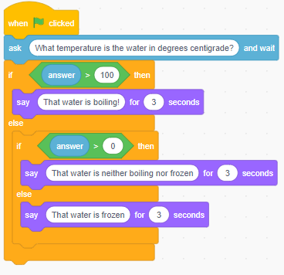
Part 2
Explain the three logical operators (Slide 6 and page 50).
Explain how the and operator works and how it can be programmed in Scratch (Slides 7–9 and page 50).
Explain how the or operator works and how it can be programmed in Scratch (Slides 10–11 and page 50).
Explain how the not operator works how it can be programmed in Scratch (Slides 12–13 and page 51).
Ask students to complete Activity 5.2: What is the weather like? (Page 51/Worksheet 5.2, plus Evidence document 5 and Slide 14).
There are GIFs in the presentation to show students what should happen when they run the programs. The activity also contains extension activities.
Common misconceptions
Students often write conditions such as: if answer >50 and <100. This can be understood by humans but will not work in programming as the computer will not understand what 100 needs to be compared to; the variable name needs to be used in every comparison. Highlight this by explaining that the computer will read the second part of the condition as ‘if <100’ . Without saying what should be <100 the instruction makes no sense and so cannot be carried out.
Example answers
(See screenshot below and Activity 5.2 solution)
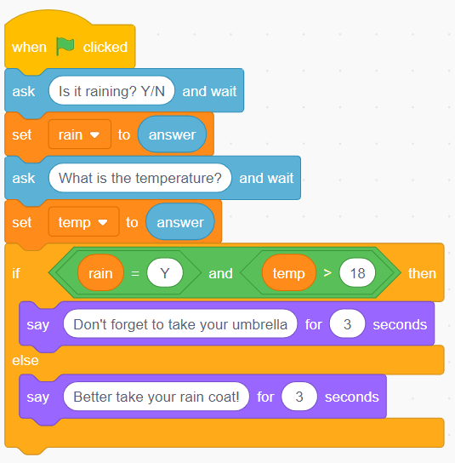
Extension
(See screenshot below and Activity 5.2 Extension solution)
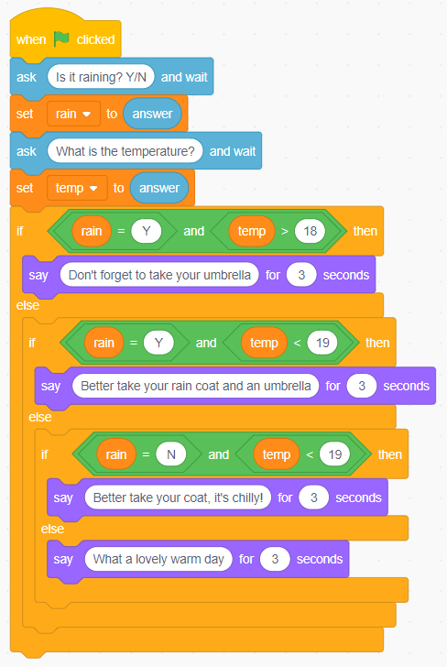
Ask students to complete Activity 5.3: Same! (Page 51/Worksheet 5.3, plus Evidence document 5 and Slide 15).
There are GIFs in the presentation to show students what should happen when they run the programs. The activity also contains extension activities.

Example answers
(See screenshot below and Activity 5.3 solution)
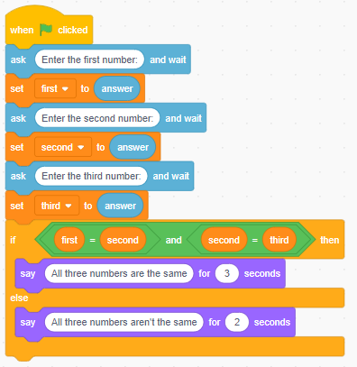

Extension activity 1
(See screenshot below and Activity 5.3 Extension 1 solution)
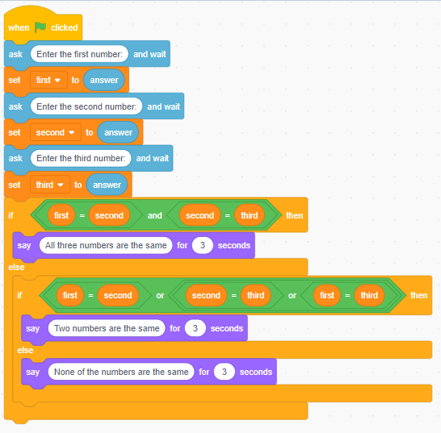

Extension activity 2
(See screenshot below and Activity 5.3 Extension 2 solution)
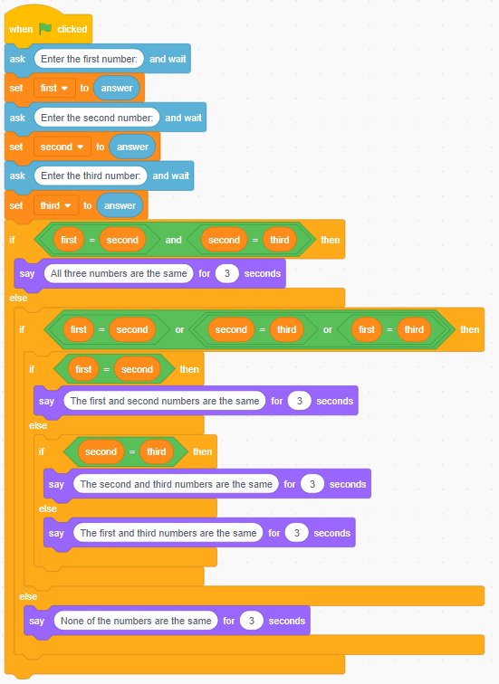

Plenary
Check students' knowledge and understanding with a short question and answer session linked to the learning objectives for the lesson (Slides 16–21 and page 51).
- How many conditions need to be true for the and operator to return True?
(Answer: two)
- How many conditions need to be true for the or operator to return True?
(Answer: at least one)
- What is the problem with the and operator in this program?
(Answer: The program will always return FALSE because there is no value that can meet both conditions. A number cannot be simultaneously more than 50 and less than 50.)
- What would this program output?
(Answer: FALSE. Both conditions are not met; the score is not more than 50.)
- What would this program output?
(Answer: TRUE. At least one condition is met; the colour is equal to Blue.
- What would this program output?
(Answer: TRUE. Neither condition is met with the OR, therefore it would be FALSE, but as it has a NOT placed around it, it outputs TRUE.)
Homework
Ask students to complete Quiz 5 (Slide 22).
Stretch activities
Students who complete the activities in this lesson quickly could be encouraged to extend their programs to compare 4 or 5 different numbers. They could also be challenged to think of examples where NOT could be used successfully in a conditional statement.
Support activities
Some students may benefit from working in pairs to complete these tasks. They may find it helpful to write down the outcome for each condition being checked and use these to decide what the overall outcome of the statement will be. For example, if the statement uses AND, then both parts must be True for the overall outcome to be True, whereas only one needs to be True if the OR operator has been used. This approach can be used when trying to decide which operator is needed in a program.

